Ex. No. 1 | STUDY OF RPA DEVELOPER ROLE AND DISPLAYING  THE WELCOME MESSAGE
Date of Exercise | 04/12/2025

AIM
To study the role of an RPA Developer and understand the UiPath Platform components (Studio, Orchestrator, and Robot) by creating a simple automation workflow that displays a Welcome Message.
DESCRIPTION
This experiment introduces the fundamentals of Robotic Process Automation (RPA) and the responsibilities of an RPA Developer. RPA is a technology that allows software robots to mimic human actions on digital systems such as opening applications, entering data, clicking buttons, and making rule-based decisions. It is mainly used for processes that are manual, repetitive, rule-based, and have minimal exceptions.
In this experiment, the UiPath Platform is studied, which consists of:
- UiPath Studio for designing automation workflows visually,
- UiPath Orchestrator for managing, monitoring, and controlling robots,
- UiPath Robot for executing the automation process (Attended or Unattended).
As a basic hands-on activity, a simple automation is developed in UiPath Studio to display a Welcome Message, helping learners understand how workflows are created and executed in RPA

PROCEDURE:
1) INSTALLING UI PATH:
Step 1: Go to UIpath.com.
Step 2: In UiPath website go to Try UiPath Free.
Step 3: Sign up using your kmail.
Step 4: After sign up verify through kmail and it will direct you to this page
Step 5: Click Download UiPath Studio and UiPath studio setup execution file will download.
Step 6: Open the exe file it will take few minutes to open.
Step 7: Select UiPath studio pro. You will get this window.
Step 8: To work on project go to process. Create a process by giving a name and click open main workflow.
Step 9: This is the UiPath studio Workflow.

2) Displaying a welcome message in UiPath studio:
Step 1: Open UiPath studio and click process to start a new project.
Step 2: Create a new blank process by giving a name and give create.
Step 3: Click Open main workflow.
Step 4: You will get the main workflow.
Step 5: In Activities search message box. Click and drop it in the activity area.
Step 6: Type the message text inside double quotes - “……”
Step 7: Run the sequence.

OUTPUT:
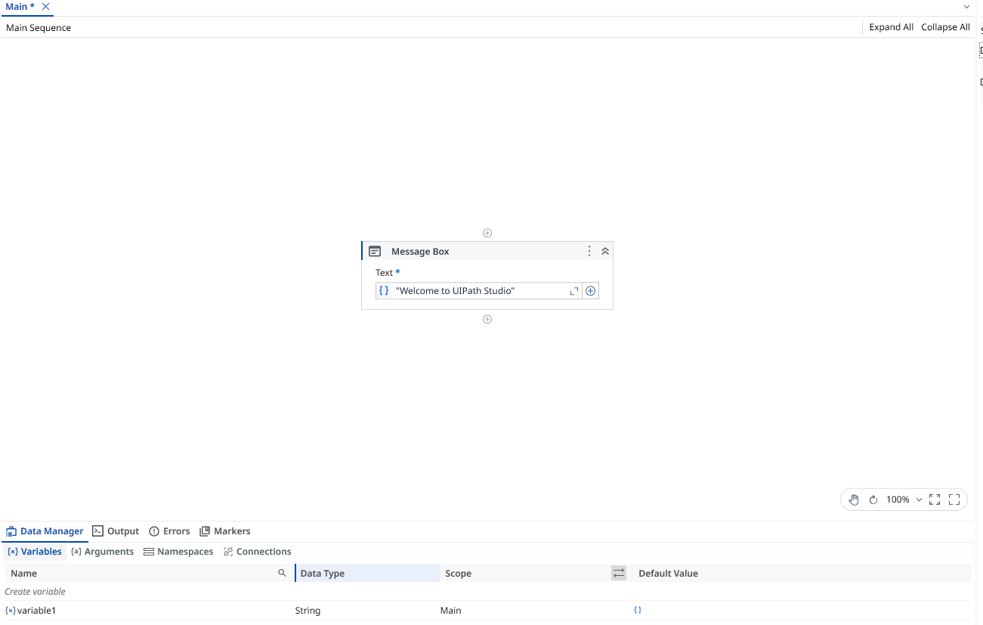

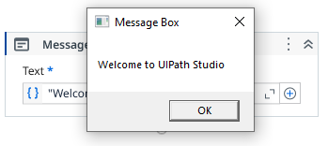

Result
Thus, the role of an RPA Developer and the components of the UiPath Platform were studied successfully, and a simple automation workflow was created and executed to display the Welcome Message successfully.

